Master Functional Document

Application | NGERP - Centra
Service Bundle | Master Management
Service Request | Manage Scheduler

Description :

The scheduler master is used to run the scheduler and to keep log of the Database jobs start and end time.

Workflow Process :

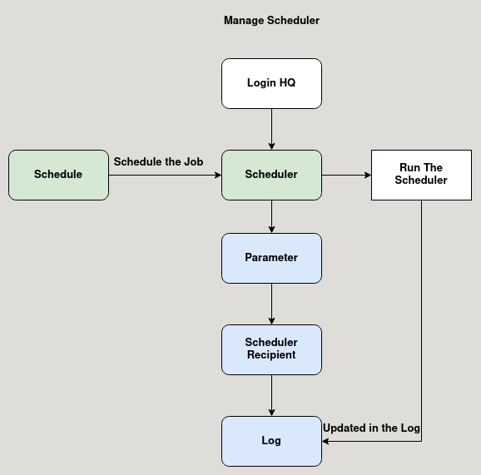

Business Rules :

- Click test run to run the Database job, after the job completed it shows success message.
- A schedule is mapped to the scheduler master to run the job at specific time and day.
- Either the job is success or failure, user can check the details in the log tab.
- The scheduler recipient tab is used to map user to with email alert about the job status is sent.

